EXPERIMENT-7
NAME: Yuvaraj A ROLL NO:240701809
Experiment with different design structures and color palettes for the application and Gather user feedback WireFrame Designs with difference color palettes:
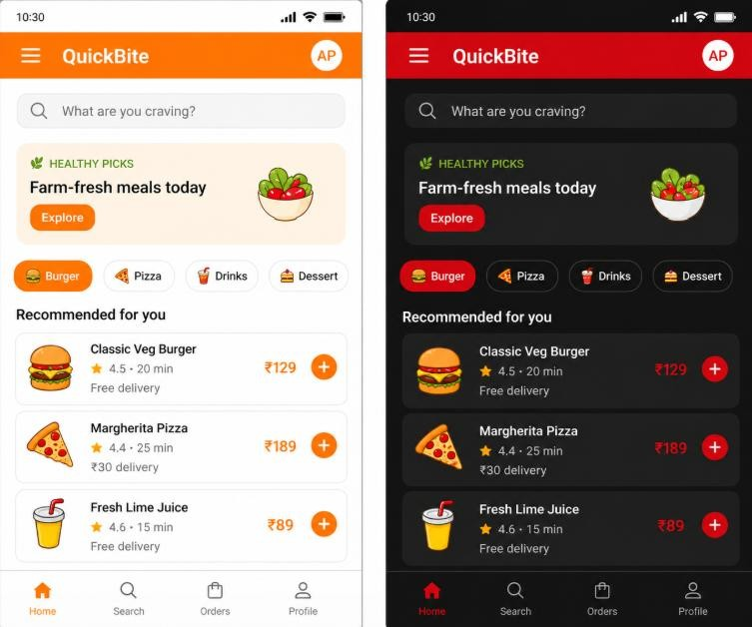

Orange Theme (QuickBite Light)
This version uses an orange color theme, which gives a fresh and energetic feel. The layout includes a header, search bar, food categories, item cards, and bottom navigation. The light background with orange highlights makes the screen clean and easy to read. Overall, this design gives a friendly and attractive food ordering experience.

Red Theme (QuickBite Dark)
This version uses a red color theme with a dark background. The layout remains the same as the light version, including search bar, categories, food cards, and navigation menu. The red highlights give a bold and modern look, making the design stylish and eye-catching.
However, dark colors may feel slightly strong for long usage.

Google form link:
https://docs.google.com/forms/d/e/1FAIpQLSdcpNbMe590g6Xd5i3a-
2Y1o0yt59IXCLu56f8NvkOm9oLMDdlg/viewform?usp=publish-editor

User Feedback :
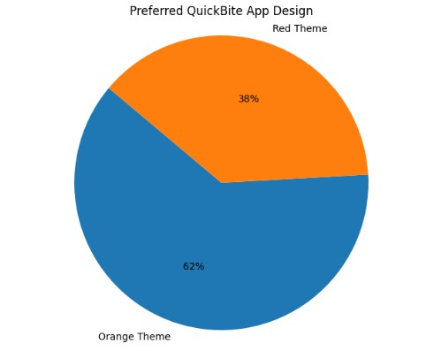

User Feedback Collection :
- A Google Forms form was created to collect user feedback on the QuickBite Food Ordering App design.
- The form was shared with users to evaluate different color themes and layouts.
- Users were asked to give their ratings on visual appeal, readability, usability, and overall experience.

Result :
Orange theme received the highest user preference. Users found it more attractive, clean, and comfortable for regular usage. The light layout and clear text improved readability and overall usability.

Conclusion :
Color and layout greatly affect user experience. Using GIMP, different UI designs were created and analyzed. The experiment shows that users prefer clean, simple, and readable designs such as the Orange Theme for better aesthetics and usability.

